Meta Title:
Best Houston Structural Remodeling Contractors in Texas
Meta Description:
24/7 top-notch Houston Structural Remodeling services? Our structural services deliver excellence. Trust the best for your home expansion needs.
https://houstoncustomcarpets.com/services/structural-services/ | Houston Structural Remodeling | 10
 | Structural Remodel | 110
 | room addition | 1.6k
 | structural repair services | 390
 | Home Addition Contractors | 2,9k
 | home addition contractors near me | 3.6k

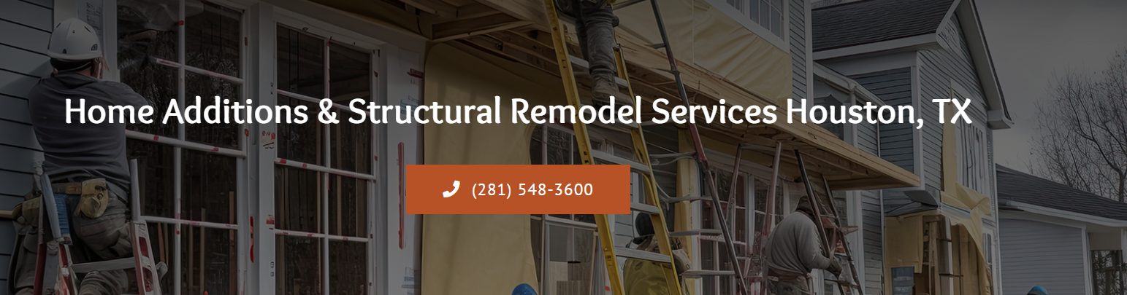
Houston Structural Remodeling (H1)

Houston Custom Carpets – Your Houston Structural Remodeling Service Provider (H2)

At Houston Custom Carpets, we offer a complete package embracing the greatest Houston Structural Remodeling services. Our team of experts has years of experience and unmatched dedication towards providing you with the best quality services that help transform your homes and businesses into something that you always have envisioned. Our team brings a wealth of experience to the jobs, and we are therefore able to provide fully customized services whether the client needs the design of a new home, a commercial building, or simply repair work.

Schedule Your Free Consultation Today

360° Structural Remodeling Solutions for all Kinds of Needs (H2)
Here at Houston Custom Carpets, we recognize that changing the look of your area means investing your time and money. Our team is focused on offering integrated Structural Remodeling solutions that will help to solve all challenges of your project. From initial consultation to the finishing of the design phase, we develop the construction plan, followed by the actual building and installation of the equipment and machines with a detailed cleaning up at the end of the installation process. In this way, we provide a full service that not only ensures quality but also steers your project in the right direction.

Get Your Estimate Now

Our Structural Remodeling Services: Live Comfortably with Style (H2)
If you are looking for the best home addition contractors near me in Houston then Houston Custom Carpets is your one-stop solution. Whether you want to reconfigure your room or add new ones, our contractors are 24/7 ready to take on any kind of task.
Home Additions | Basement Finishing
Want to increase your home size? At Houston Custom Carpets, our Home Addition Contractors provide the best solutions when it comes to home additions to first-floor, second-floor addition, master bedroom addition, bedroom addition, bathroom addition, living room addition, and home office additions with utmost care. | At Houston Custom Carpets, we offer the solution for the undesirable and unused unfinished basement; let us turn it into a flexible and practical area. Our professionals design functional and comfortable spaces appropriate for your particular and favorite use, such as a theater room, play area, or bedroom.
Kitchen & Bath Remodeling | Room Reconfigurations
Renovate your home’s central system – the kitchen and bath – with our kitchen & bath remodeling solutions. Our team of skilled professionals will assist in enhancing the functionality and aesthetics of your design. Select from a variety of options in material, lighting, and other fittings as per your comfort. | Discover the true value of rooms you already have with Houston Custom Carpets, serving clients throughout the Greater Houston area. From changing a layout, constructing built-ins, or redesigning already existing spaces, our team can assure high-quality success and a guarantee that we will not exceed your financial means.
Structural Rehabilitation & Recovery | Custom Lumber, Cabinet & Millwork
We know that disasters and other factors can affect the structural quality of your premises. That's why we offer structural repair services and solutions that will have your home or office looking brand new. Ranging from simple problems, leakage and faulty foundations, we guarantee that your property is not only secure but also beautiful. | Want to improve the interior aesthetics of your home? Get in touch with Houston Custom Carpets to get custom cabinets and special work today. Our skillful team of carpenters will provide you with original high-quality cupboards according to your needs for built-in bookshelves, kitchen cupboards, or simply carving work.

Check Out Our Game-Changing Structural Remodeling Process (H2)

Here at Houston Custom Carpets. our process is fully customized to meet diverse requirements from the right from the very first day to the last day.

Consultation & Design | Project Planning & Estimation
First, our team comes to your home to have a consultation with you in order to learn what you expect. We then offer elaborate works that employ 3D models to allow a client to visualize how their interiors will look. | Once the design is approved by you, then our team creates the project life plan and gives an estimate of the overall cost of the project. This helps to keep your project very much on schedule and at a fixed price.
Permits & Construction | Final Inspection & Clean-up
We ensure all the legally required permits and approvals have been made. And after that, our construction team gets to work in order to accomplish your dream with years of Experience, sheer commitment, and dedication. | Before our work is complete, our team inspects everything to make sure it meets your expectations. We then tidy up the area, understandably, giving your area a boost in terms of tidiness when you began with us.

Experience the Difference with Houston Custom Carpets? (H2)

At Houston Custom Carpets every project that we undertake adheres to certain core business values including, quality, design, and customer satisfaction. Here are a few reasons why you should choose us for your structural remodeling needs:

Full Customization | Comprehensive Expertise
Every single service that we offer is unique because we guarantee customers results that win their hearts. | Professionals of Houston Custom Carpets have many years of practice within this sector, which guarantees good outcomes.
High-Level Transparency | Attention to Detail
We embrace regular feedback with our clients ensuring that you are constantly in touch with us during the entire remodeling period. | We pay particular attention to every minute detail so that every facet of your remodel is done with the uttermost precision.

FAQ’s
:

How long a typical remodeling project will take? (H3)

The time taken to complete a remodeling project is usually influenced by the time required to work on the project. Freelance work may range from relatively small size usually being accomplished in a week to large-scale work extending to several months. We will give you a comprehensive timeline before embarkation on the planning process of your project.

What will be the cost of the remodeling job? (H3)

Various factors influence the total cost of your remodeling project which include;
- Complexity of design
- Existing plumbing and electrical work
- Material selection
- Room size
- Permits and inspections

Our team will offer you an individual quote depending on your requirements and would be glad to assist you at any stage if necessary.

Will my project lead to major interference in my routine activities? (H3)

Our professional experts will ensure that you are not so inconvenienced when going through the process of remodeling. Moreover, our employees organize their working shifts in a manner that excludes the most crowded time, while they maintain a clean working environment. Although sound and dust cannot be completely avoided, we make every effort to minimize them.

Do you offer full services in your company to fully remodel my home? (H3)

Yes, we take on every aspect of the whole remodeling job; therefore, you do not need to look for other contractors. We have skilled personnel in matters concerning carpentry, flooring, drywall, and any other aspect that may be required for a good remodeling job.

How do I determine that the services being sought are suitable for my needs? (H3)

Here is our list of the services we are proud to provide concerned with different structural requirements. First of all, our team will outline your goals in his project and then explain which approach might be most suitable for you. If what we have offer here interests you then we will be glad to help you redesign your home.

